University of Cambridge

Database name

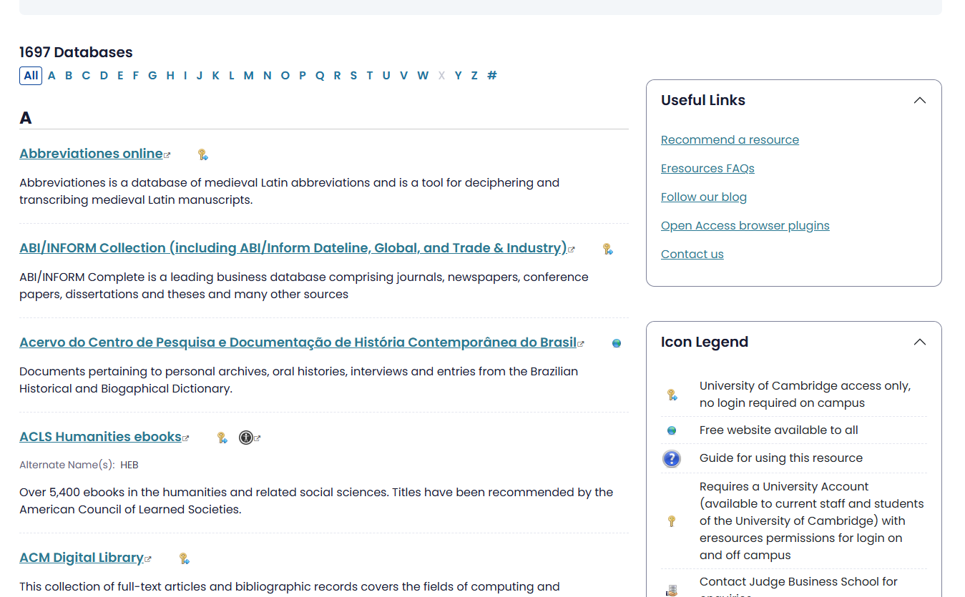

Product Description

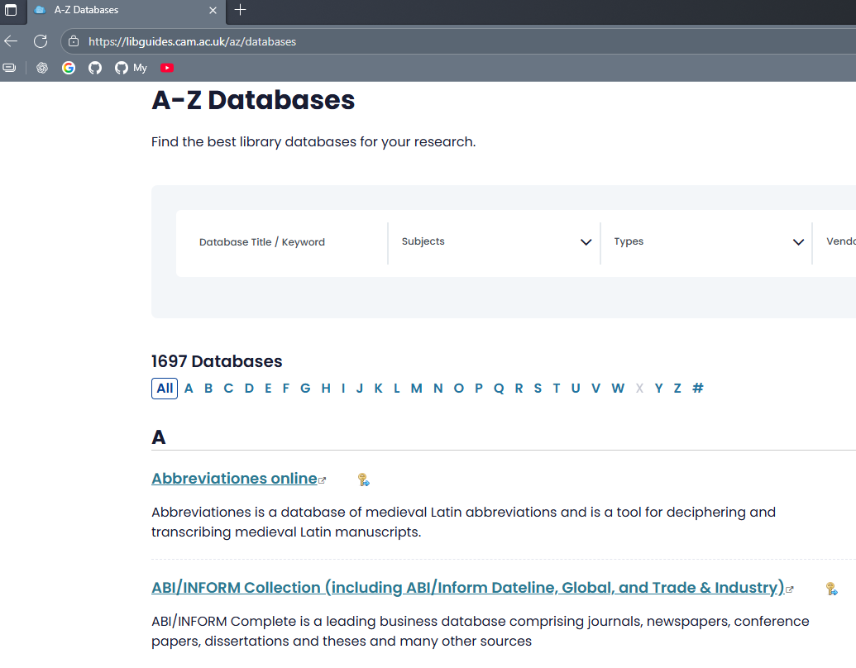
Source URL
INNODATA COMMENT:
- There is no clarification regarding the “Subject Area”.
- Vendor Name information is not displayed on this site.

